
Olivet’s Enrollment Code: CD7L2LB213L27 or use the QR Code.
Order Scrip Online
- Log into Shop All Gift Cards • RaiseRight
- Browse the categories on the home page and select a retailer.
  - Top of the page has Today’s Bonuses. These are usually higher percentages than the retailer’s normal percentage.
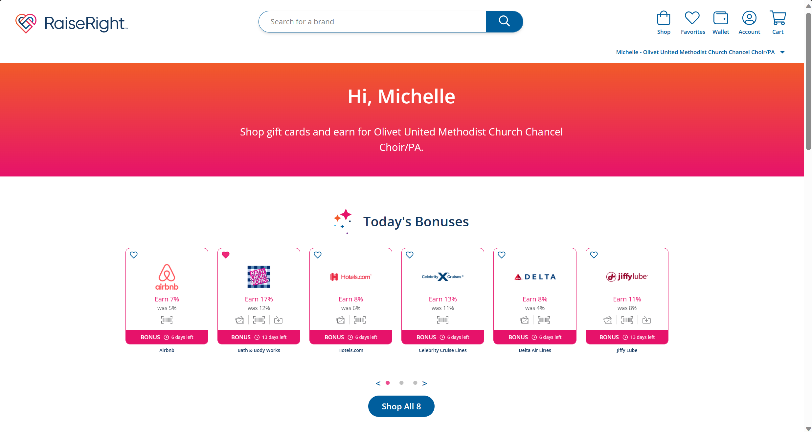
- Select if you want a physical card, eGift, or Reload. Enter the amount and quantity. Click Add to Cart.
  - Physical cards are gift cards that are shipped to your organization or mailed directly to you if ship-to-home eligible. This option is ordered on the 1st Sunday of each month by 8:00 p.m.
  - eGift are digital gift cards that are delivered electronically and automatically saved to your Wallet.
  - Reload will add funds to physical gift cards you’ve already purchased.
Physical Card | eGift
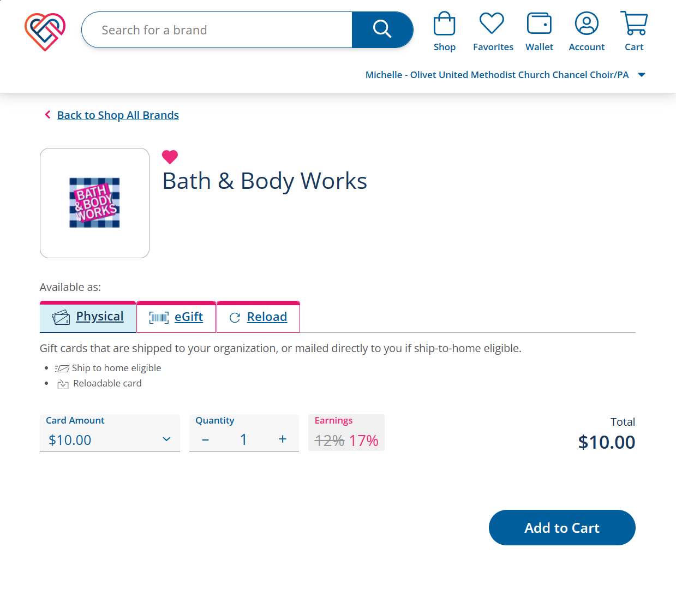 | 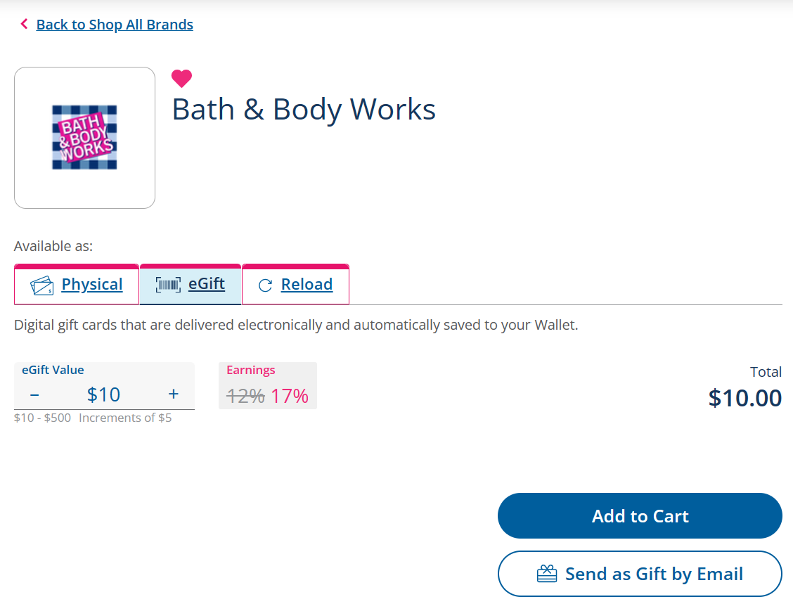
- If you are done shopping, select View Cart.
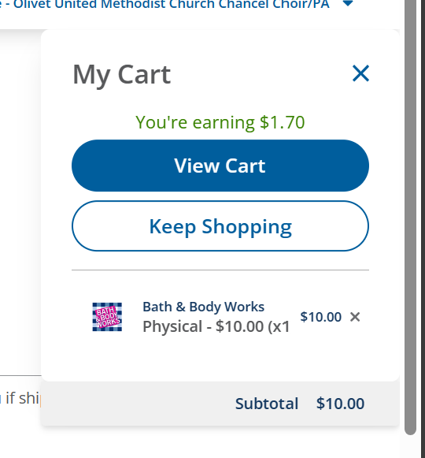

- On the “Cart” page, review your cart. If correct, select Begin Checkout.
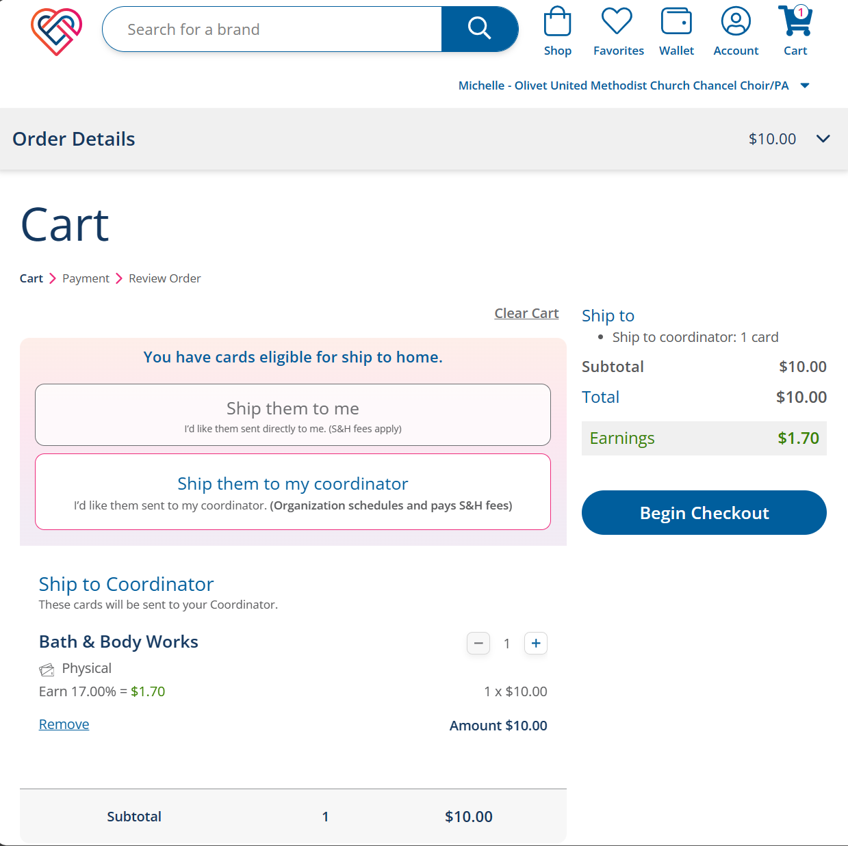
- On the “Payment” page, select your payment method. Click on Continue to Confirm Order.
  - Pay Coordinator Directly by either giving Michelle a check or Citadel members can transfer the funds via OLB.
  - Bank Account will deduct the funds right from your account for a $0.29 ACH Fee for the entire order.
  - Credit Card will charge your card for a fee of 2.6% for each credit card transaction.
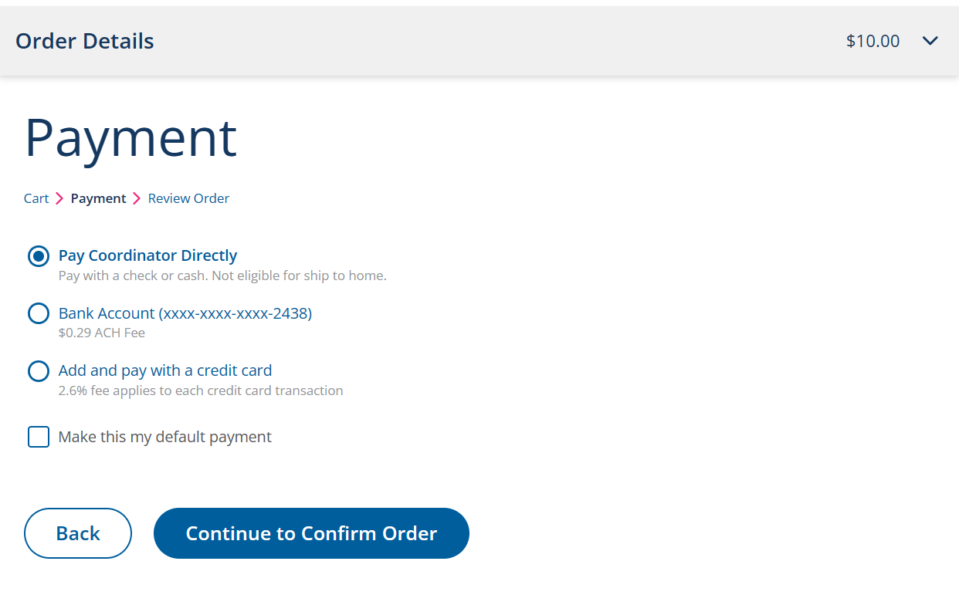
- On the “Review Order” page, select Place Order.
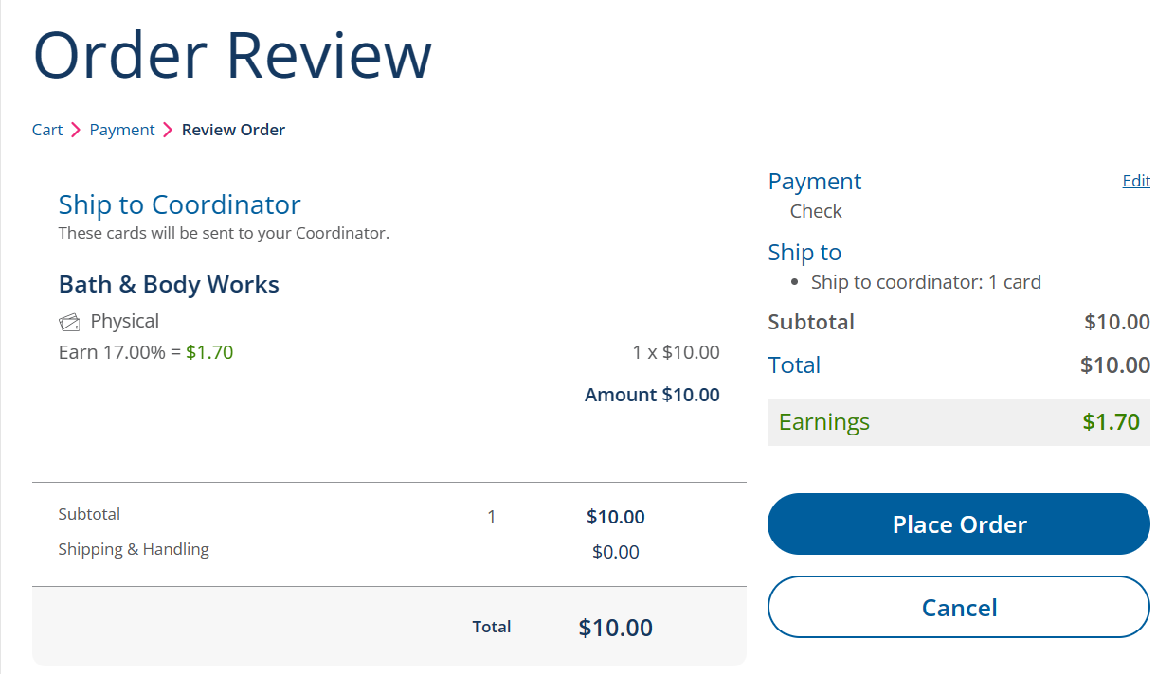
Order Script on the Raise Right App
- Login into the Raise Right App
  - Google
  - Apple
- Browse the categories on the home page and select a retailer.
  - Top of the page has Today’s Bonuses. These are usually higher percentages than the retailer’s normal percentage. These change daily.
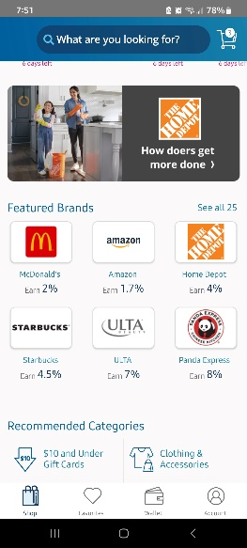
- Select if you want a physical card, eGift, or Reload.
  - Physical cards are gift cards that are shipped to your organization or mailed directly to you if ship-to-home eligible. This option is ordered on the 1st of the month by 8:00 p.m.
  - eGift are digital gift cards that are delivered electronically and automatically saved to your Wallet.
  - Reload will add funds to physical gift cards you’ve already purchased.
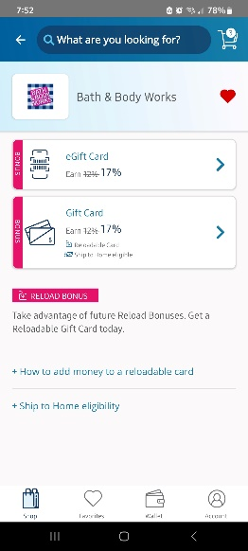

- Enter the amount and/or quantity. Click Add to Cart.
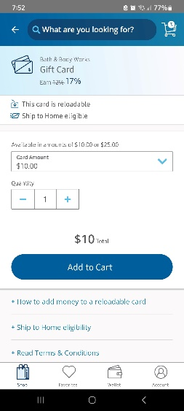
- If you are done shopping, select Go to Cart.
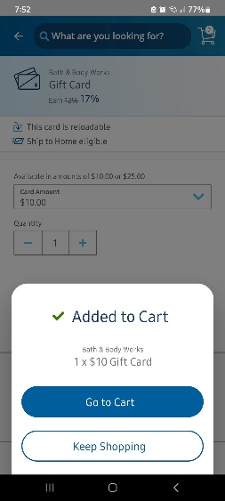
- On the “Cart” page, review your cart. If correct, select Continue to Checkout.
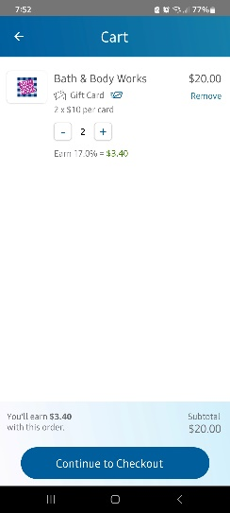
- On the “Payment” page, select your payment method. Click on Continue.
  - Pay Coordinator directly by either giving Michelle a check or Citadel members can transfer the funds via OLB.
  - Bank Account will deduct the funds right from your account for a $0.29 ACH Fee for the entire order.
  - Credit Card will charge to your card for a fee of 2.6% of each credit card transaction.
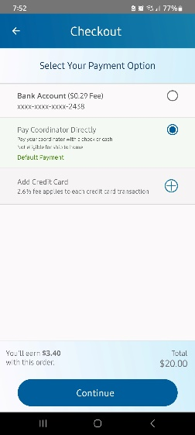
- On the “Review Order” page, select Place Order.
